NSDD Flavor Drill March 2026

This is Document LA-UR-26-21973. Approved for public release; distribution is unlimited
Title: NSDD Flavor Drill March 2026
Authors: David J. Mercer, Jennifer Auxier.
Date: 16 March 2026
We gratefully acknowledge Will Johnson (SNL), Erik Swanberg (LLNL), Jacob Stinnett (LANL), Russell Malchow (RSL), and Angela Moore, Mitch Woodring, Dylan Toneff, Isidro Garcia, Forrest Runkle, Adrian Garza, Kevin Litke, and Kevin Bertschinger (PNNL).
Introduction
This exercise examines the use of geolocation information. Knowing where a measurement was collected may help an analyst understand the context (for example, whether an elevated reading occurred near a structural feature or medical facility). Difficulty level is 6/10.
Many mobile radiation detection platforms—including handheld instruments, backpack systems, and vehicle mounted systems—record latitude and longitude using an integrated Global Positioning System (GPS) receiver. Mapping tools (for example, Google Earth) can be used to display the location. Alternatively, if you upload a file into InterSpec that includes coordinates, a prompt will appear: “On-board RIID Results. File contains GPS coordinates. Show on map.” Selecting this option opens an ArcGIS-based map that plots the location (or locations) associated with the measurement.
​
For each question, the primary dataset is provided in ANSI N42 format, with each file containing a time-ordered sequence of measurements. Please use the N42 file as the basis for your analysis whenever possible. If necessary, extracted foreground and background spectra are also provided in SPE format.
​
You can access all files for this drill here: https://sandialabs.github.io/InterSpec/example_problems/flavor_of_the_month/#march-2026
You may download the latest version of InterSpec, which has useful updates, here: https://github.com/sandialabs/InterSpec/releases/tag/bleeding-edge
​

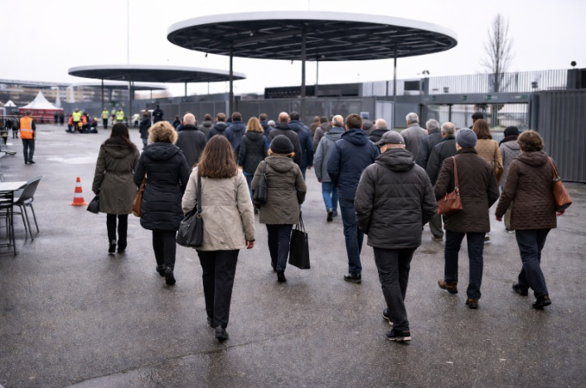
Question 1:
An individual was stopped by security personnel in a public location after ionizing radiation was detected. The detection occurred at coordinates 45.479462° N, 9.124727° E. The person’s medical history shows that they received radioembolization treatment for liver cancer four days earlier. See file Q12 Patient.N42.
Which venue is located near these coordinates?
☐ National University Hospital (NUH), Singapore
☐ Universitätsklinikum Essen (Essen University Hospital), Germany
☐ Levi’s Stadium, Santa Clara, California, USA
☐ Stadio Giuseppe Meazza (San Siro Stadium), Milan, Italy
☐ London Heathrow Airport (LHR), UK

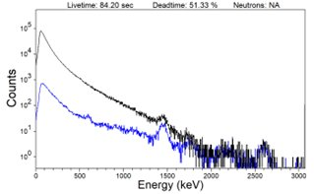
Question 2:
The measured gamma-ray spectrum is mostly featureless. It consists mainly of a broad, continuous distribution of energies extending above 1.8 MeV. See file Q12 Patient.n42.
Which is the most likely radiopharmaceutical source of the detected radiation?
☐ Technetium-99m–labeled macroaggregated albumin (⁹⁹ᵐTc-MAA)
☐ Gallium-68–labeled macroaggregated albumin (⁶⁸Ga-MAA)
☐ Holmium-166–loaded poly-L-lactic acid microspheres (¹⁶⁶Ho-PLLA; QuiremSpheres®)
☐ Yttrium-90 glass microspheres (TheraSphere®) or Y-90 resin microspheres (SIR-Spheres®)
☐ Phosphorus-32–labeled microspheres

Question 3:

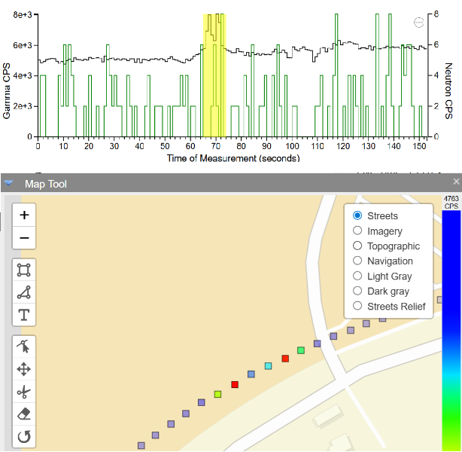
A radiation detection team was deployed near the Circuit of the Americas racetrack in Texas (a major motorsports facility). The team was equipped with a Radiation Solutions Inc. (RSI) mobile detection system with two NaI(Tl) gamma-ray scintillator detectors (each 5.08 cm × 10.16 cm × 40.64 cm). While monitoring the area the team observed two reproducible excursions above the background rate background near 30.138122° N, 97.640622° W. These excursions are shown here highlighted in yellow in the time histogram and as red squares on the map tool. If using the InterSpec Map Tool, the Imagery button is recommended. See file Q345 Circuit.n42.
What might influence the gamma count rate near the specified location?
☐ River Crossing
☐ Roadway Overpasses
☐ Mountains
☐ Skyscrapers
☐ Vehicle with radiopharmaceutical source

Question 4:
What radionuclides are associated with the excursions?
☐ Tc-99m
☐ Pu-239
☐ I-131
☐ Ga-67
☐ Naturally-occurring radioactive materials only (NORM)

Question 5:
The neutron rate during the excursions is slightly larger than the average background rate.
Is the difference statistically significant?
☐ Yes
☐ No

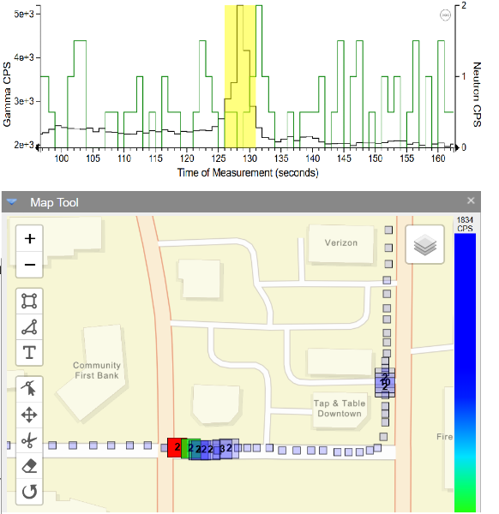
Question 6:
During a survey by a vehicle-mounted detector system, a count rate excursion above background was observed. The detector system consists of four NaI logs, each measuring 5.08 cm × 10.16 cm × 40.64 cm which are combined to make two virtual detectors. The excursion occurred at the location 46.28047° N, 119.27503° W. See Q67 Mobile Excursion.n42
Are any medical centers near this location (within 1 kilometer)?
☐ Yes
☐ No
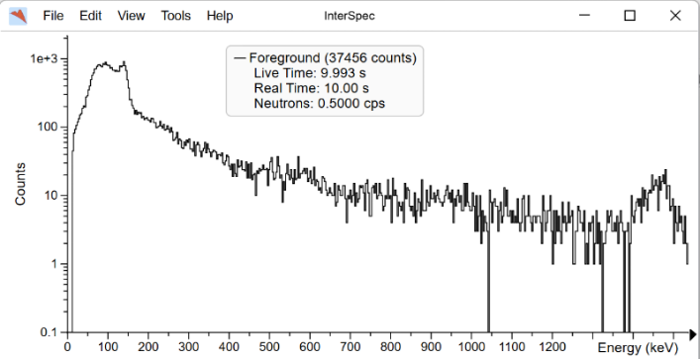
Question 7:
What medical radionuclide is visible at this location?

☐ Ga-67 (used for imaging inflammatory diseases and some tumors)
☐ I-131 (used for treatment of thyroid diseases)
☐ Tc-99m (used for a variety of diagnostic imaging procedures)
☐ Y-90 (used for treatment of tumors by radioembolization)
☐ F-18 (used for positron emission tomography)
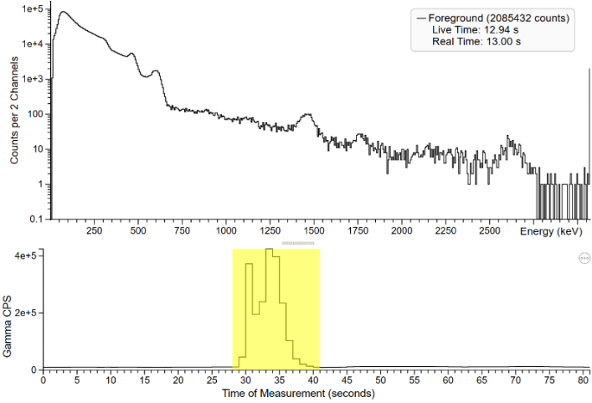
Question 8:
A helicopter flyover detected a radiation hot spot near 30.438430° N, 91.218520° W. See Q8910 Helicopter.N42
What type of industry is present at this location?
☐ Shipyard with Dry Dock
☐ Petroleum Storage Facility
☐ Nuclear Power Plant
☐ Pipe Manufacturing / Spool Yard
☐ Oil or Natural Gas Refinery

Question 9:
What radionuclide is visible at this location?
☐ Ar-41
☐ I-131
☐ Ir-192
☐ Pu-239
☐ U-235

Question 10
Is the radionuclide you identified from the spectrum (Question 9) consistent with the location you identified (Question 8)?
(1 Point)
☐ Yes
☐ No

